WELCOME TO HARTISMERE
A-LEVEL DRAMA



2024-2026
Mrs Davy

You are part of our Hartismere Drama Family; in our family we have expectations…
- Believe in each other
- Support each other
- We are a team in drama ‘all of us’
- Contribute your ideas and opinions
- Listen and value other people’s views
- Understand that you may have differing opinions but that is you’re right, however
- Always be mindful of other people’s feelings.
- Be brave there is no wrong answer when it comes to creating, collaborate and be adventurous and innovative.
- Do not put a ceiling on the possibilities challenge yourself, be as creative as you can
- Be independent, yet collaborative, use divergent thinking, make sure you use a growth mindset and most of all
- Attend all lessons
- Attend all theatre shows
- Working together as a group is key, but this must mean that there is no ridicule
- You will all have strengths and weaknesses; you need to therefore support each other
- You will need to read in front of each other, again support is crucial
- Complete all homework for the deadline
- Turn up to rehearsals after school and during lunch breaks
- When I or your peers are talking, you’re not, when you’re talking I’m not and nor are you’re peers, key to working well together and getting a good grade is mutual respect
- Everyone is entitled to their opinion; you listen and then you can give your own

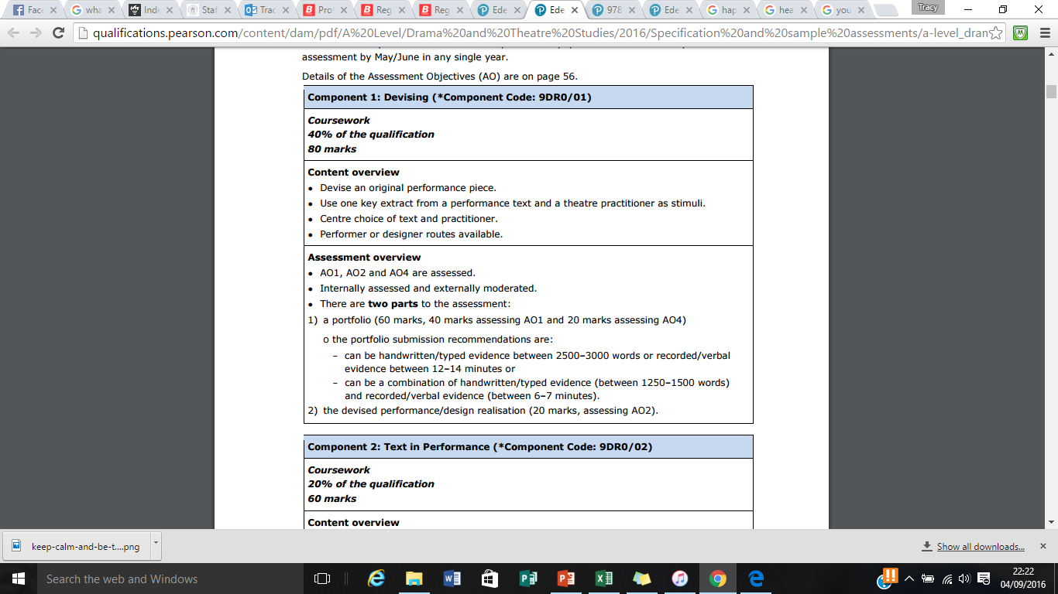
COMPONENTS

In a nutshell:
One devised performance from a stimulus (the same as GCSE-except the stimulus is a play) under the influence of a practitioner
- Practical = 10% of your grade 20/80 marks
- Theory portfolio = 30% of your grade 60/80 marks
- Portfolio is like the one you did at GCSE but its 2500-3000 words and must include knowledge and influence of your practitioner
These will be assessed by me and moderated by Edexcel

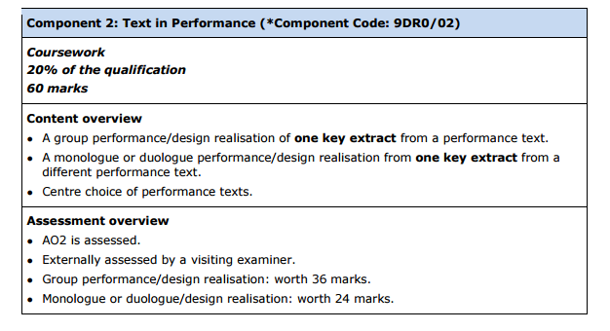

In a nutshell:
- A monologue or a duologue 40% of C2 24/60 marks
- A group scripted performance 60% of C2 36/60 marks
- Assessed by an external examiner in the Spring term

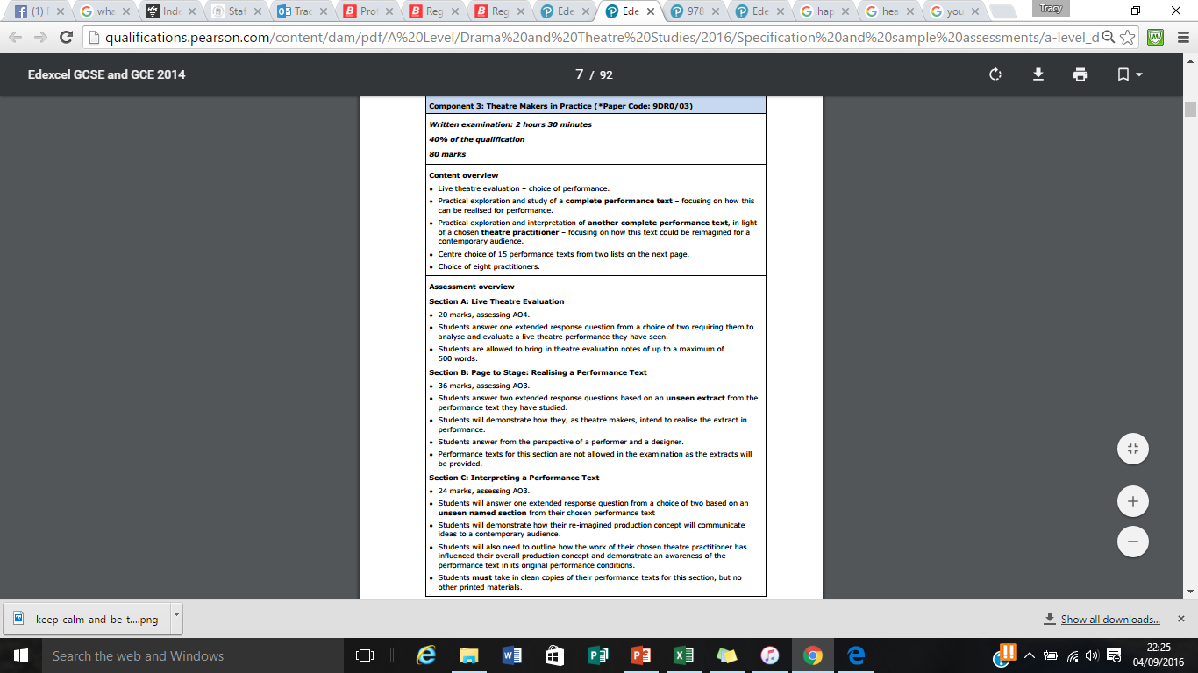
In a nutshell:
- SECTION A – 1 QUESTION ON THE LIVE THEATRE REVIEW BASED FROM A SHOW (Like GCSE- 20 marks)
- SECTION B – 2 QUESTIONS ON EQUUS (36 marks)
- SECTION C– 1 QUESTION ON WOYZECK (24 marks)
How to Survive Drama A – Level

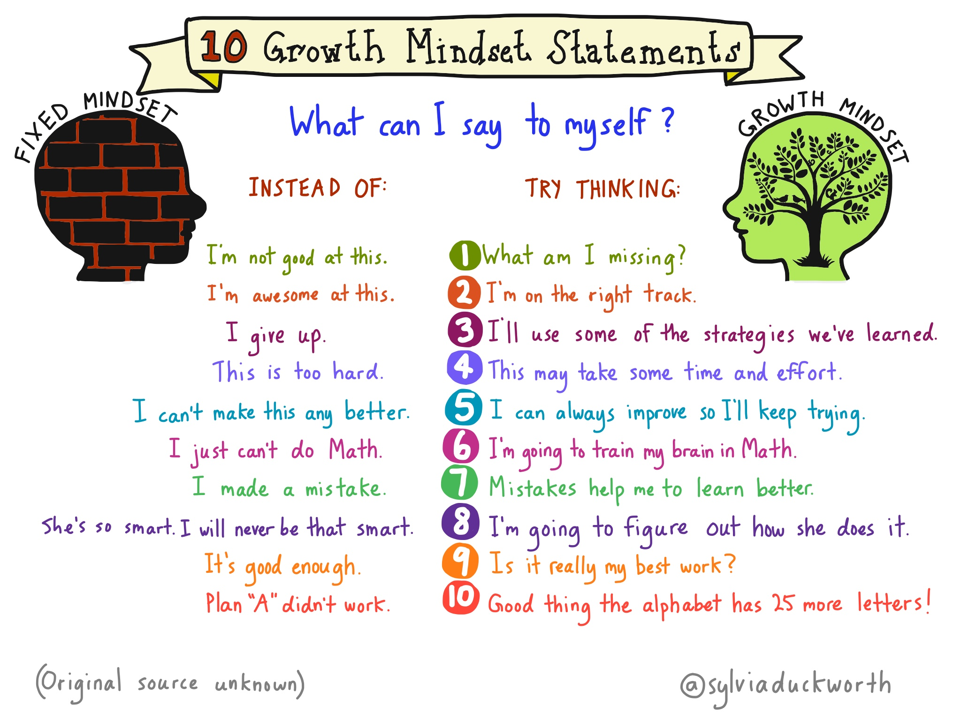

Get ahead with the reading texts!
- AN ACTOR PREPARES- Constantin Stanislavski
- The Complete Stanislavsky Toolkit by Bella Merlin
- The Complete Brecht Toolkit- by Stephen Unwin
(No need to but these texts they are available from libraries)
See as much live theatre as possible! You could:
- Sign up to mousetrap C145 to get £5 tickets to West End Shows!
- Sign up to the National Theatre Entry Pass to get £5 tickets!
- Sign up to young Barbican for £5 theatre tickets
- Sign up to RSC Key to get £5 Shakespeare shows – you can also opt to stand at the Globe for just £5
- Open air theatre BREEZE – gives you £10 tickets
- Young Vic give you £10 tickets if you are under 26!
- Donmar Warehouse Young Free – FREE TICKETS TO THEATRE SHOWS – NO CATCH! Sign up to them.
- Hampstead downstairs club £5 tickets – sign up
- Almeida Theatre does £5 tickets for those under 25, use the UNDER25 code
- Tricycle Theatre £10 tickets
- Sign up to Digital theatre and watch plays for free (Read terms and conditions).
- The National Theatre and the Globe theatre are showing numerous shows online for free- log into their websites for further info.
WEST END is GREAT! BUT ! These shows make ideas easy to replicate and have some stunning work! They are also super cheap so you can see a new show every weekend if you wanted!
Advice from previous students:
“Be confident and ready to try new things, make sure you throw yourself into everything asked of you, even if it’s out of your comfort zone”

"Never give up. Drama is a very hard subject, but I've learned that being determined is the best way forward. Work with each other. Do not be afraid of teamwork because you'll need to embrace it fully and it can be so rewarding"

“Make sure that everything is organized into different sections of your folder. Keep EVERY exam you do because it will help towards your progress… HAVE FUN!”

- Opportunities to work with the community and professionals
- Autumn Workshops TBC:

Take part in any workshops that you can over the summer break. Contact theatres local to you to see what they have on offer.
Planned theatre trips:

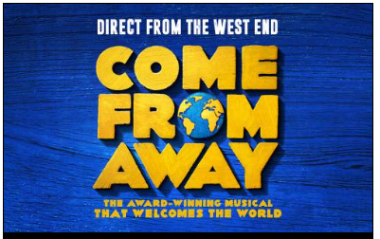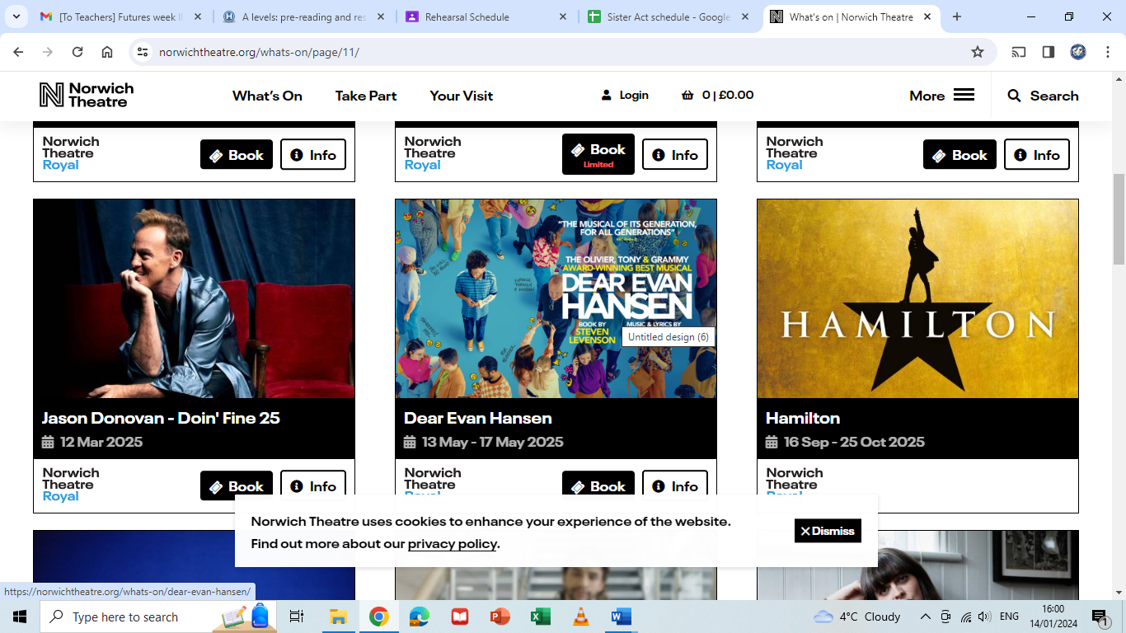
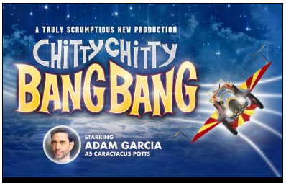
Now, your first assignment!
Below is a list of Practitioners, it will be useful for you to know who these people/companies are and how they influence your work. E.g. Brecht likes to use Placards in his work so you might use them as well.
Peter Brooke | Constantin Stanislvaski | Punchdrunk | Rudolph Laban | Complicite
Bertold Brecht | Steven Berkoff | Joan Littlewood | Frantic Assembly | Artaud

I would like you to complete the following questions and activities based on the methodologies of
Constantin Stanislavski:
- What is a practitioner?
- What is the difference between style/genre?
- What style does this practitioner use?
- Create a presentation on this Practitioner
- Create a workshop of 10 minutes which you will lead, to explore how this practitioner works
- Extension task- If you have time, repeat the task focussing on the work of Brecht.
This is due the FIRST LESSON BACK in September 2024. Any questions please do not hesitate to contact me jda@hartismere.com

